**(a)(i)**

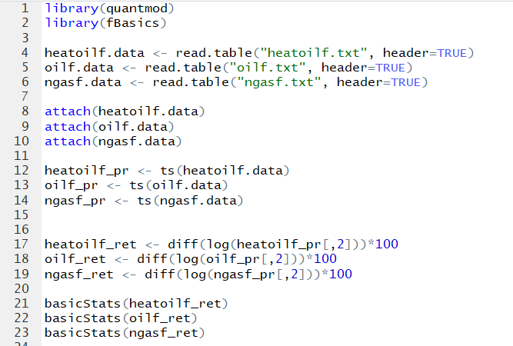

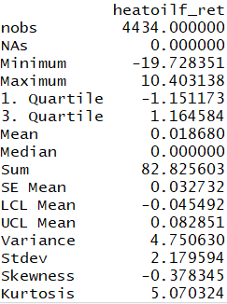 Minimum = -19.728351

Maximum = 10.403138

Sample Mean = 0.018680 (average daily return)

Standard Deviation = 2.179594

Skewness = -0.378345

Kurtosis = 5.070324

**Summary statistics for heating oil log returns (futures contract)**

# 

Minimum = -16.544513

Maximum = 16.409725

Sample Mean = 0.018334 (average daily return)

Standard Deviation = 2.338884

Skewness = -0.064957

Kurtosis = 4.461237

**Summary statistics for crude oil log returns (futures contract)**

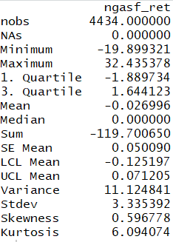 Minimum = -19.899321

Maximum = 32.435378

Sample Mean = -0.026996 (average daily return)

Standard Deviation = 3.335392

Skewness = 0.596778

Kurtosis = 6.09407

**Summary statistics for natural gas log returns (futures contract)**

**Sample Mean**

$$\overline{r}=\frac{1}{T}\sum_{i=1}^{T}{r_{i}}$$

Sample mean is the average value (log returns of futures contracts in this case) over the sample period (1st of January 2001 to 29th of December 2017). It captures the central tendency of returns. If the sample mean value is positive, it shows that the investors have positive gains (returns) over the period on average. Meanwhile, if the sample mean value is negative, it shows that the investors have negative gains (returns) over the period on average.

**Futures contract for heating oil log returns**

0.018680 * 252 = 4.70736% (annual rate for the return)

The futures contract for heating oil log returns have increased by 4.70% on average per annum.

**Futures contract for crude oil log returns**

0.018334 * 252 = 4.620168 (annual rate for the return)

The futures contract for crude oil log returns have increased by 4.62% on average per annum.

**Futures contract for natural gas log returns**

-0.026996 * 252 = -6.802992 (annual rate for the return)

The futures contract for natural gas log returns have decreased by 6.80% on average per annum.

**Conclusion**

From 1st of January 2001 to 29th of December 2017, it shows that futures contract for heating oil log returns have the highest positive return (4.70%) on average per annum and futures contract for natural gas log returns have the lowest negative return (-6.80%) on average per annum.

**Standard Deviation**

$$sd=\sqrt{\frac{1}{T-1}\sum_{t=1}^{T}{ {\left(r_{t}-\overline{r}\right)}^{2}} }$$

The standard deviation is the degree of deviation from the sample mean. In finance, standard deviation is a measure of risk / volatility faced by investors. Hence, the higher the standard deviation, the higher the risk faced by investors. While the lower the standard deviation, the lower the risk faced by investors.

**Futures contract for heating oil log returns**

The standard deviation is 2.179594.

**Futures contract for crude oil log returns**

The standard deviation is 2.338884.

**Futures contract for natural gas log returns**

The standard deviation is 3.335392.

**Conclusion**

From 1st of January 2001 to 29th of December 2017, futures contract for natural gas log returns have the highest standard deviation which means it has the highest risk (biggest spread around the sample mean). Meanwhile, the futures contract for heating oil log returns have the lowest standard deviation which means it has the lowest risk (lowest spread around the sample mean).

**Skewness**

$$skewness= \frac{1}{T}\sum_{t=1}^{T}{{\left(\frac{r_{t}-\overline{r}}{s}\right)}^{3}}$$

Investors are interested in whether the mean value are more likely to be negatively distributed or positively distributed too. The skewness measures the amount of asymmetry in a distribution. The larger the absolute size of the skewness, the more asymmetrical is the distribution. Skewness of a normal distribution is equal to 0.

**Futures contract for heating oil log returns**

The skewness -0.378345.

This shows that the returns of heating oil futures contracts are negatively skewed. Investors can expect frequent small gains and a few large losses.

**Futures contract for crude oil log returns**

The skewness is -0.064957

This shows that the returns of heating oil futures contracts are negatively skewed. Investors can expect frequent small gains and a few large losses.

**Futures contract for natural gas log returns**

The skewness is 0.596778

This shows that the log returns of heating oil futures contracts are positively skewed. Investors can expect frequent small losses and few large gains.

**Conclusion**

Futures contracts for heating oil log returns are the most negatively skewed in this example which means the investors can expect frequent small gains and a few large losses from their investment. Meanwhile for futures contract of natural gas log returns, investors can expect frequent small losses and a few large gains from their investment.

**Kurtosis**

$$kurtosis= \frac{1}{T}\sum_{t=1}^{T}{{\left(\frac{r_{t}-\overline{r}}{s}\right)}^{4}}$$

Kurtosis shows investors whether there is a high possibility of extreme positive or negative excess returns (without looking at the sign). Kurtosis measures the thickness of the tails of a distribution. The higher the kurtosis, the thicker the tails of a distribution. Investors can expect occasional extreme returns (positive or negative) if it has high kurtosis. If the calculated kurtosis is bigger than 3, it is considered as high kurtosis. If it is lesser than 3, it is considered as low kurtosis.

R calculates excess kurtosis and the kurtosis for a normal distribution is 3.

**Futures contract for heating oil log returns**

The excess kurtosis is 5.070324 (In R). Hence, the kurtosis is 5.070324 + 3 = 8.070324

**Futures contract for crude oil log returns**

The excess kurtosis is 4.461237 (In R). Hence, the kurtosis is 4.461237 + 3 = 7.461237

**Futures contract for natural gas log returns**

The excess kurtosis is 6.094074 (In R). Hence, the kurtosis is 6.094074 + 3 = 9.094074

**Conclusion**

Since all three samples have high kurtosis, it indicates that investors will encounter occasional extreme returns, more extreme than the usual positive or negative three standard deviations from the mean that is predicted by the normal distribution of returns (kurtosis risk).

Besides that, as all three samples have excess positive returns, it indicates that all three distributions have heavier tails and a sharper peak than a normal distribution. Futures contract for natural gas returns has the highest positive excess returns while futures contract for crude oil returns has the lowest positive excess returns.

**(a)(ii)**

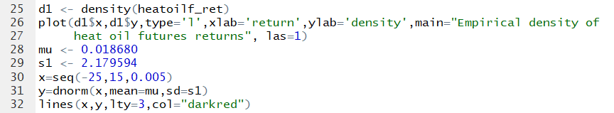

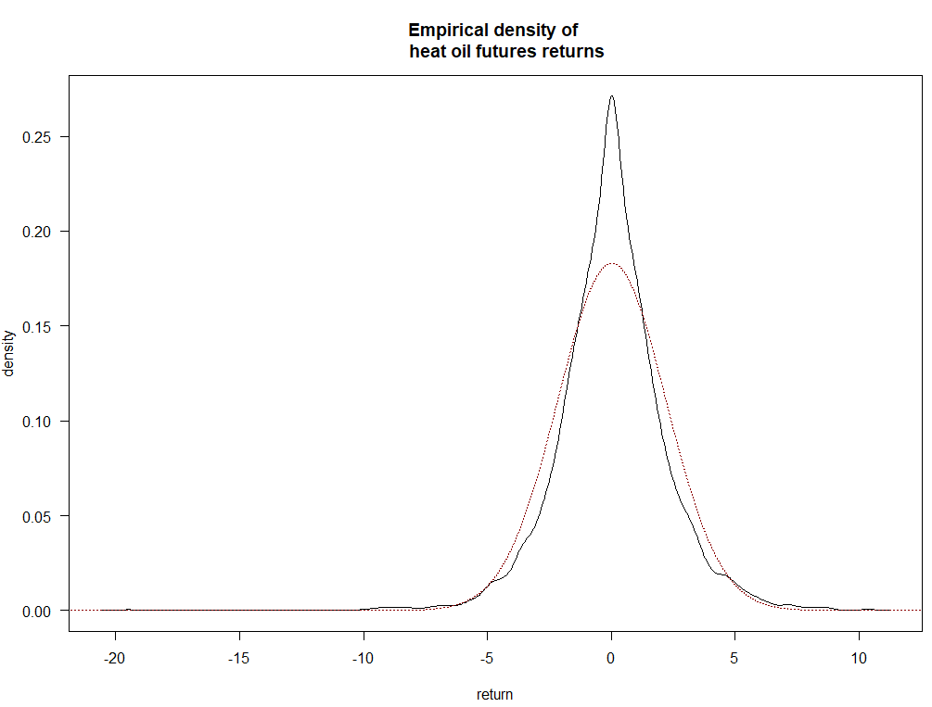

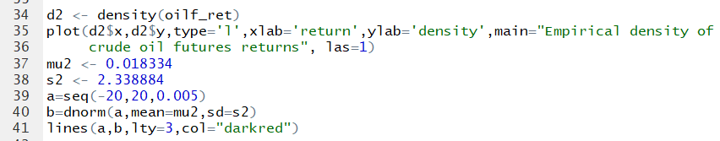

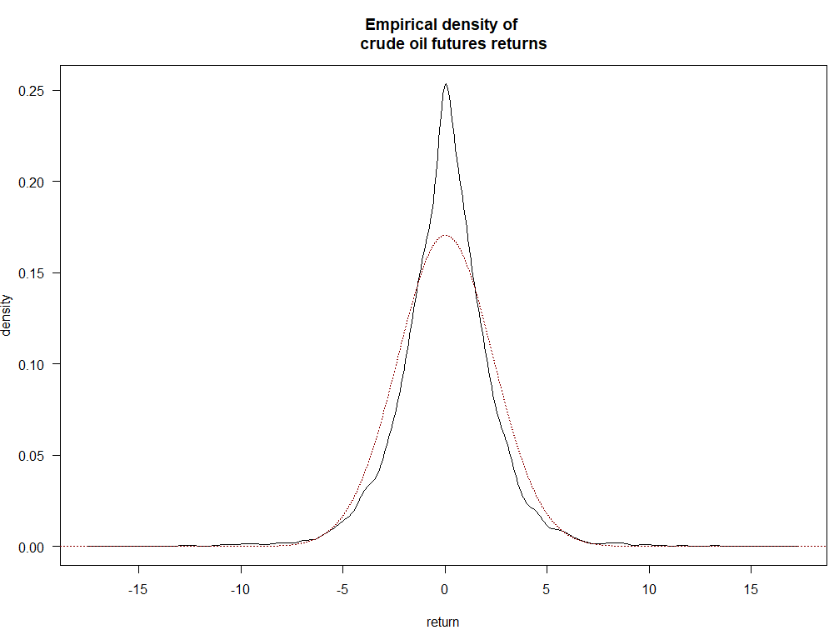

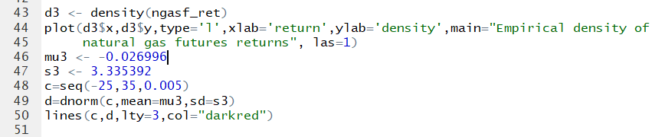

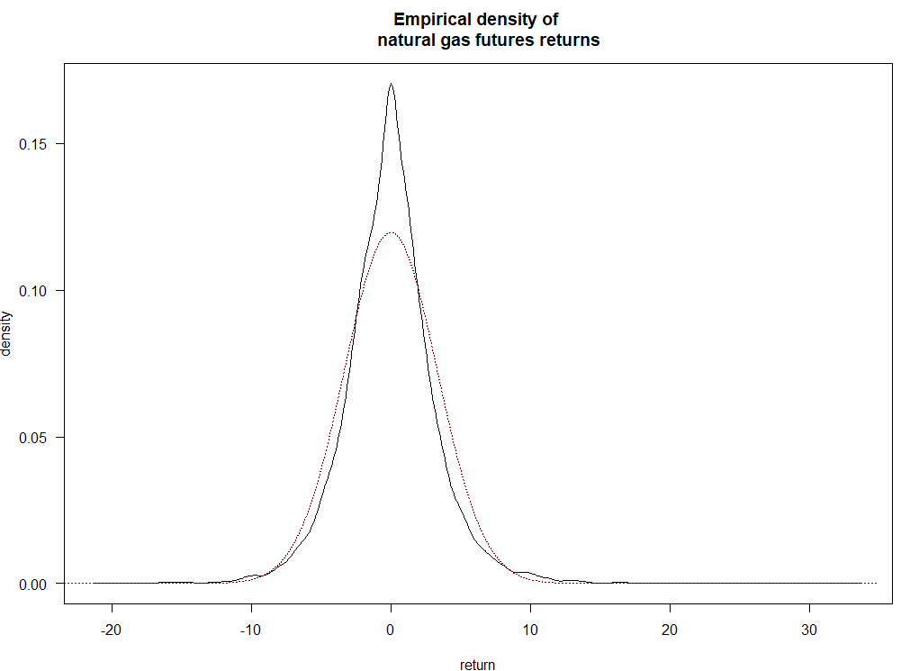

**Conclusion**

Red lines: normally distributed

Black lines: not normally distributed

The log returns are not normally distributed because as shown above, all three empirical density plots have different shapes compared to the normally distributed plot. Besides that, from the part (a) (i) above, all three samples have a skewness (normal distribution has skewness of 0) and they have excess kurtosis (normal distribution has a kurtosis of 3).

**Normality test (Jarque-Bera)**

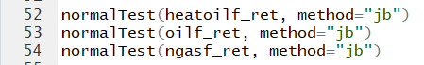

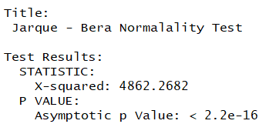

**Heating oil (futures contract)**

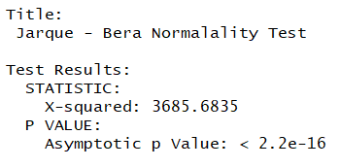

**Crude oil returns (futures contract)**

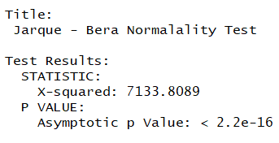

**Natural gas returns (futures contract)**

**Jarque-Bera test**

$$b_{1}= \frac{E(u^{3})}{{\left(σ^{2}\right)}^{\frac{3}{2}}}$$

$$b_{2}= \frac{E\left[u^{4}\right]}{{\left(σ^{2}\right)}^{2}}$$

**Jarque-Bera test statistics**

$$W=T[\frac{b_{1}^{2}}{6}+\frac{{\left(b_{2}-3\right)}^{2}}{24}]\sim χ^{2}$$

Null hypothesis: data is normally distributed.

Alternative hypothesis: data is not normally distributed.

Test-statistics: All 3 samples have large values (4862.2682, 3685.6835 and 7133.8080)

P-values: All 3 samples have small p-values (2.2e-16)

Decision: |T-statistics > T-critical values|, p-values < 0.01. We reject the null hypothesis.

Conclusion: We reject the null hypothesis and conclude that the data (all 3 samples) are not normally distributed.